**Combe Down Allotments, Church Road, Bath BA2**

**Background and Issues**

**Bulletin No 1, February 2024**

**Summary**

**This bulletin sets out the social and historical significance of the Combe Down Allotments site, which lease for which was procured 130 years ago for the benefit of mine workers, by leading figures in the Parish of Monkton Combe (now Combe Down). The site has been run on rolling leases by the Council since 1967.**

**Whilst the Upper Lawn Bath stone quarry adjacent to the allotment site is recognised as importance to the wider city, a number of quarry extensions over time have detrimentally affected the size and shape of the allotments, most recently in 2018. The site now has 64 plots, with the potential for more and there is a waiting list of 50 people. There is a serious shortage of allotments overall in the city.**

**In 2019 the Council requested a 15 year lease but was only offered a 5 year lease, and the right to access the site (by car or foot) from the Glen Field was initially withdrawn, leaving only one pedestrian gate off the adjacent public footpath (The Drung). After negotiation, the landowner gave a right of way along the existing track, but took out the parking area, the woodchip bays and the track from the lease on the assumption that these would be provided off St Winifred’s Drive, along with a further set of plots on set-aside land to increase the capacity of the site – a scheme which he fully supported at the time.**

**Delays occurred to this scheme as the Council resolved that in the interests of fairness to all stakeholders, including local residents, a planning application would be made. This was despite the fact that planning permission was not needed. However, in November 2023, the landowner unexpectedly announced that he was giving the Council advanced notice that the 130 year old lease would cease in 2025. The Council has had no explanation of why he has taken this decision and have stopped work on the planning application.**

**The community was devasted by this sudden threat to a much loved allotment site. Local action was immediately galvanised by the Allotments Association (AA) and the community is now running a campaign to save this site for the future. A petition has been signed by over 5,000 people (1,000 of which are on paper).**

**A separate paper explaining in detail the Local Plan Policies and the effect of the relationship between the Mineral Protection Policies, the Allotment Protection policies and Local Green Space designations, on this site, is also posted on the Allotments Association website.**

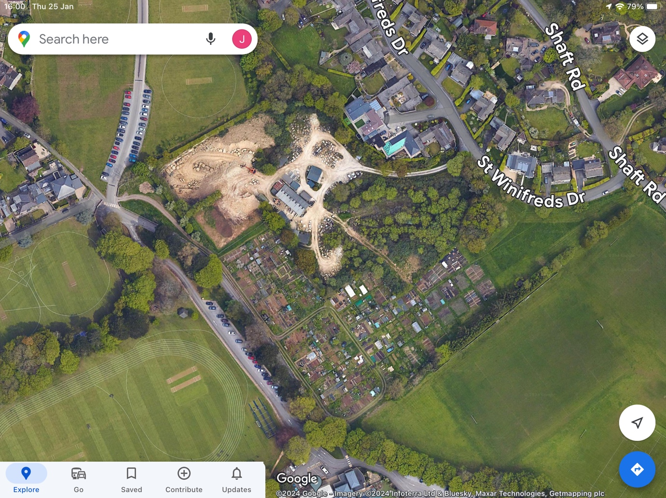

**Introduction**

Combe Down’s simple allotment gardens have played an important role in the life of the village for more than 170 years. Their history is inextricably linked to the first Vicar of Combe Down, the Revd. George Newnham (1806-1893), a keen gardener. He created the first village allotments in 1851 on land near the church, in an effort to tackle the poverty and social issues affecting his parishioners, many of whom laboured in dangerous conditions in the local Bath stone quarries, which were first established in the village in the early 1700s.

Since then, several allotment sites in the village have come and gone - mostly lost to house building. In 2024, just two remain: ten Council-owned statutory plots on the Bradford Road at Foxhill and 64 plots and associated grassed areas on privately owned land at the western end of Church Road (now known as Combe Down Allotments). In the meantime, the village has grown to encompass more than 3000 homes and there is a long waiting list for plots.

The peaceful and productive allotment site in Church Road is integral to Bath’s working-class social history. Created in 1895 by Monkton Combe Parish Council on 6.5 acres of farmland in response to demand from the villagers of Combe Down, this unassuming local green space, hidden away within the World Heritage area that encompasses Bath and its Skyline, is easily forgotten amongst the more glamorous and world-famous buildings and crescents. The crops these simple allotments have produced and the social interactions they have encouraged have sustained an important local community for generations.

**1895 - History, ownership and location of the Church Road/Shaft Road allotment site**

In February 1895, Monkton Combe Parish Council voted to find suitable land to rent in the village to satisfy a demand for allotments for both the wards of Combe Down and Monkton Combe. In March, six and a half acres of tenanted farmland on the outskirts of Combe Down were made available for the purpose by Mr Joseph Law of Combe Grove Farm, in response to the Parish Council threatening to use its compulsory powers under existing legislation.[1] The land, which stretched eastwards from the end of Church Road and across to what is now Shaft Road, skirting Upper Lawn Quarry, was owned by Colonel Vaughan-Jenkins of Combe Grove Manor, but was tenant-farmed by Mr Law.

**1960’s – decline and loss.**

The site was originally six and a half acres, but this was reduced when St Winifred’s Drive was built in the late 1960s. The contemporary Parish Council minutes record that allotment holders were required to leave their plots at short notice when construction began without warning. In 1967 Local Authority boundary changes meant the tenancy of the site passed from Monkton Combe Parish to Bath City Council, now B&NES Council, which has been leasing and running the site ever since as part of its statutory holdings of 24 sites in the city.

**1968 – new landowner.**

In 1968, on the death of William Vaughan-Jenkins, ownership of areas of land in Combe Down, including the allotment site, Upper Lawn Quarry, Glen Field and Rockery Tea Gardens passed to his relatives, members of the Lovegrove family, and thence to the current owner, Mr Richard Lovegrove, who lives in Liverpool. In 2014-15, in a joint venture with Freemantle Developments, Mr Lovegrove developed his land at Rockery Tea Gardens for housing, having been granted planning permission in 2008.[2] [3] This is now Rockery Park, accessed from North Road.

**Quarry Extensions: 2000 and 2016**

Upper Lawn Quarry is the last remaining active quarry in Combe Down. It is leased from Mr Lovegrove by John Hancock & Sons and is accessed from St Winifred’s Drive. The lease expires in 2035. It is believed to have begun circa 1850 at North Road (where Rockery Park has since been built) and quarried progressively southward to its current location. The original workings, partly backfilled, are still visible as a large depression occupied by Rockery Park (formerly Rockery Tea Gardens). Later workings were filled and levelled, or built over at a lower level to create the western end of St Winifred’s Drive.[4]

Extensions to the quarry have absorbed numbers of allotment plots over the years. Plots were lost to a southern extension in the 1990s and in 2000 a western extension absorbed a further nine of the original Combe Down allotment plots.[5] Land that had been earmarked for replacement allotments to the south was never forthcoming and remains inside the quarry’s boundary fence (see plans associated with the planning application).

**2016 – Quarry applies for planning permission to extend into the allotments.**

In 2016 the Quarry applied for planning permission for a second western extension.[6] This meant the loss of a further twelve allotment plots at the northern end of the allotments. This application made no provision for replacement allotments, and so a local campaign was mounted to ask the landowner and quarry operator to reinstate the lost allotments on alternative land. This included oral representations to the Council’s Planning Committee. In 2017, the Council’s Planning Department required the quarry operator to make an application for planning permission for 12 replacement plots, on the original allotment land that had been laid to grass in the 1990s.[7] This cited “change of use to an area of paddock land for use as allotments”, despite the fact that there was no change of use, as the site was already within the allotments lease and has been used as such. Permission was granted on 27 February 2018 and it lapsed without being implemented 3 years later on 27 February 2022.

**2018 – quarry extension approved.**

Planning permission for the quarry extension was granted on 27 February 2018, subject to several conditions. Condition 4 required the quarry operator to reinstate the 12 lost allotments using the land to the south of St Winifred’s Drive (which had always been part of the allotments) before stone extraction could begin. However, quarrying commenced without the replacement plots being provided and the Council did not take any action. 12 replacement plots were eventually set out by the Quarry and they were offered to new tenants in September 2022, some four years after the original plots had been vacated, resulting in loss of income to the Council, with some plotholders leaving altogether. The Quarry never did not fully complete the work, as required on the approved plans.

**2019 - Combe Down Users Group set up.**

In the light of the potential issues facing the site, such as the closure of access from Glen Field being sought by the landowner and the Public Right of Way diversion being promoted by the Monkton Combe school, the AA set up a Combe Down Users Group (CDUG) in May 2019, chaired by the Association’s site representative, Chris Pearce. The aims of the CDUG were to secure the long term future of the site and to act as a forum for better engagement with the Council. This included pressing the Council to reinstate the set-aside area to the east as allotments and approaching the Quarry and the Monkton Combe School for an open discussion about working together, although neither responded.

**2019 - Public Right of Way Diversion**

In February 2019, the Council wrote to advise allotment tenants that the Monkton Combe School wished to reroute the Public Right of Way from Combe Down to Mount Pleasant, known locally as The Drung, to run inside the existing allotment site, alongside the wall. At the same time, the landowner expressed the intention to withdraw the right for vehicles and pedestrians to access the allotments via the large gateway off Glen Field/Church Road, leaving only a small pedestrian gate off The Drung.

Two public meetings were held, chaired by the then B&NES Director of Environment. The then Bursar of Monkton Combe School was also present. The residents of St Winifred’s Drive were invited to the first meeting, and the allotment tenants/general public were invited to the second. Neither of the two groups heard each other’s concerns or suggestions for ways forward. This may well have played a part in creating the various misunderstandings and impasses that appear to exist today.

A proposed layout for the Public Right of Way diversion was tabled by the Monkton Combe School and the CDUG submitted written comments and design suggestions (not objections) to the School in November 2022. Most of the comments were accepted in principle by both the School and the Council Parks Team, who were acting as agent for the diversion application.

**2019 – lease negotiations**

In 2019 the landowner agreed to extend the allotments’ lease to five years, but the new lease did not include the vehicular access into the allotments from Glen Field/Church Road, or the strips of land just inside the gateway on either side. The Council was therefore negotiating a new lease for the allotments, while at the same time needing to establish a safe replacement access for vehicles into the allotments. The lease was finally amended to include an easement for right of access along the existing vehicle track. This lease expires on 1 April 2024.

**2021 - Proposal to reinstate allotments on the set-aside area.**

In March 2021, in light of the growing waiting list and the pressure from the landowner to relocate the vehicle access, the AA promoted a scheme to reinstate approximately 10 further plots on the set-aside area to the east, in addition to the 12 plots to replace those lost for the quarry extension. The plans included communal orchards, a new low-key vehicle access from St Winifreds Drive (for safety reasons the Council considered the existing gate to be sub-standard) and small area of informal parking, on the grassed set-aside area to the east of the site. *It is important to note that none of these works requires planning permission.*  A native hedge was planted on the wide grass verge on St Winifreds Drive in advance by the Council to allow screening to grow. The project was to have been funded by money from the Mulberry Park development (called Section 106 funds) which are ring-fenced specifically to provide new allotments in the Combe Down Area. The project funding was agreed at Cabinet level, subject to a longer lease being obtained, which was at that point in time under active negotiation between the Council and the landowner.

In January 2023 the Council received notification from the landowners solicitors that he was ready to proceed with the renewal of the lease for 15 years. He also indicated that the Council should progress the project to reinstate the plots on the set-aside area. The Council then took the unusual step to complete the work on the unfinished replacement plots, despite it not being legally responsible for discharging the planning conditions. It is understood that the costs have come out of Council budgets. Given the plans to extend plots into the rest of the field, the provision of a 1.8m high chain link fence across the middle of the site was agreed between the CDUG and the Officers to be unnecessary, but after a meeting with local residents in St Winifred’s Drive, just prior to the local elections, the Council officers agreed to build the superfluous fence anyway. The AA has had sight of a letter from a senior Council officer agreeing to do this and also agreeing to remove the native hedge during the dormant season 2023/24, although this has not been done to date.

Although none of these works would have required planning permission, the Council resolved to make a planning application. A Habitats Regulations survey of the paddock area has been carried out, at cost to the Council. No equivalent consultation was, or has been since, carried out with the plotholders as potential users of the site or the Allotments Association.

The Chair of the AA met with Mr Nigel Hamilton, who said that he represented residents of St Winifred’s Drive and Shaft Road, who were objecting to the proposed reinstatement of allotments on the set-aside area. Progress was not made in resolving or properly understanding residents’ concerns, other than that they wished to retain their views and were concerned about the new vehicle access.

**2023 – lease negotiations stall.**

The Council’s current lease on the site runs out in April 2024. In the meantime, despite repeated requests from the AA regarding the situation and timing of the lease renewal, negotiations for a new longer lease stalled. It was not until 12 October 2023 that the AA was informed that the Council’s legal team had engaged with the landowner’s legal team.

On 7 November 2023 the AA was notified that the owner had unexpectedly given advance notice to the Council that he would not be renewing the lease beyond 2025. Approaches to the owner (via his solicitor) by the AA have met with no responses. It is understood that the Council has written to him asking for reasons and timescales for serving notice, but it is not known whether he, or his agent, has responded.

**2023 – Local Campaign to save the site.**

In response to this announcement, the AA and the CDUG held a public meeting held in the Combe Down Primary School on 12 December 2023. It was attended by 90 people and a petition to both the landowner and the Council was started. From this meeting a core group of campaigners is now working on a number of options to try and save the site. Further information can be found on these links:

<http://banes-allotments.org.uk> Facebook: Bath Allotments Association, Save Combe Down Allotments (+Instagram).

**The petition**

The petition has attracted over 5,000 signatures (both on paper and on-line) to date. The demands are:

* *We urge the landowner to reconsider his decision and to renew the Council’s lease of the site for long term allotment use.*
* *Should the landowner decline to renew the lease, we urge the Council to use all its powers and available resources to secure the long term future of the site for allotments managed by the Council or a community group*
* *We urge the Council to use all its powers to protect this historic allotment site from a change of use*

**2024 -25. End of the lease and implications**

The community is devastated by this decision. The landowner’s intentions for the land are not known, nor are his reasons for ending this historic lease.

Upon learning from the landowner that he intended to end the lease in 2025, the Council dropped all plans to reinstate allotments on the set-aside area. However, tenancies were still being offered on the newly created replacement plots and some people have unwittingly taken these up not realising that they might only have one growing season left. The AA/CDUG are very concerned that people will give up their plots and drift off, so that the site will quickly become dilapidated and overgrown. This needs urgent thought, if the support of the public is to be maintained.

In reality, although the landowner has stated cessation in 2025, the allotments are likely to be abandoned at the end of the last growing season before then, which is autumn of 2024. The landowner will then have to secure and maintain the site.

**Adjacent leases**

In 2027 the Hancock family’s lease and planning permission on Upper Lawn quarry runs out. The Monkton Combe School’s lease on Glen Field runs out in 2035. The school has a right of way across Glen Field for one thousand years which was established in 1907 when the Junior School (now the Prep and Pre-Prep) was built on Kingham Farm fields and relocated from Combe Villa and Welford Lodge.

**Local Green Space designation 2016**

In 2015-16, the AA made a successful application for Local Green Space designation for Combe Down Allotments, as part of the Local Placemaking Plan review. However, the designation was removed at the last minute by the B&NES Divisional Director of Development, in consultation with the Cabinet Member for Homes & Planning, on the basis that LGS designation would conflict with the pre-existing Minerals Allocations Policies. There was no prior consultation with Combe Down Councillors or with the Association. In an email to a Combe Down Councillor on 14 November 2016, the Director of Development said:

*As the Planning Policy Team Leader for B&NES has explained, the change was necessary to ensure the Placemaking Plan is effective and that two conflicting designations relating to the same area of land are not taken forward. The inclusion of two designations was an oversight and was unfortunately not spotted until the examination. The allotments fall within a mineral safeguarding area and as such may in the future be subject to a planning application for the quarrying of Bath stone, which is in short supply and may be needed e.g. for building restoration projects within the city. Whilst designation as Local Green Space is proposed to be removed the allotments would still be protected under the allotments policy. This requires that any proposal for mineral development would need to ensure that suitable and equivalent allotments are provided in an area that is accessible to the community."*

**New Local Plan - Local Green Space designation 2024**

In June 2023 the AA re-submitted the site for designation as a Local Green Space, which is part of the process of preparing the **New** **Local Plan 2022-2042**. On February 1, 2024, the Cabinet will agree a Local Plan Options Consultation, which will run until the 25 March, 2024. The Officers are recommending again that the nomination be declined, citing a conflict with the Minerals Policies in the Plan. The AA is preparing a detailed rebuttal to this approach, which it believes was not properly examined in 2016 and is subject to changing circumstances. This rebuttal will be made to the Options Consultation and will be available on the AA website.

**Other protective Local Plan Policies**.

There are other current Local Plan Policies (particularly Policy LCR8) which recognise and protect allotments. The Options Consultation is recommending that the whole site be covered by Policy LCR8 (currently the set-aside area is excluded). The AA will be submitting evidence to support this.

However, in practical terms, Policy LCR8 cannot guarantee to secure a site as allotments, as it allows for other uses, subject to replacement allotment sites being found. This is normally done through either a planning condition or a Planning Obligation under Section 106 of the Planning Acts. Due to the lack of suitable alternative sites within the required distances of the potential users’ residences, especially in Bath, neither the Council, nor anybody else, is able to find suitable alternative sites. The AA is concerned that in the case of Combe Down, should the allotment use cease, the landowner could then make the case that as allotments are no longer present, other uses could be an improvement over an empty site.

It is ironic that there is specific funding available to create new allotment plots in Combe Down. The money comes from the Mulberry Park development Section 106 Agreement. Developers are expected to provide adequate Green Infrastructure provision as part of their development, but in practice they do not want to include allotments or food growing opportunities within their sites and are only too happy to give the Council S106 money and pass on the problem and the money remains unspent. This is the case at Combe Down.

The relocation of an allotment site also results in the huge loss of high quality top soil, often organic, equipment and mature plants and fruit trees, all of which will have taken years of work to bring to optimum yields. They are a precious and dwindling resource and this is why Policy LCR8 is not a fully protective policy. To secure the long term future of the site Local Green Space designation is vital.

This Briefing note was prepared by Jacqueline Burrows (local resident and plotholder) and Jacky Wilkinson (B&NES Allotments Association Planning Officer). It will be updated regularly.

Edition 1. Date 1 February 2024

**References include:**

Monkton Combe Parish Council Minutes (Bath Records Office)

Tithe maps and Ordnance Survey Maps (BRO and National Library of Scotland)

B&NES Council website and public documents

B&NES Allotments’ Association minutes and correspondence

Email exchanges with Councillors and Council Officers

House of Commons Library website

Combe Down Heritage Society archives

Other public websites

1. Local Government Act 1894, Sections 6 and 9 as quoted in the Parish Council minutes
2. Planning reference 08/03370/FUL
3. <https://freemantledevelopments.co.uk/project/rockery-park/>
4. David Workman, *A Brief History of the Stone Quarries at Combe Down,* Journal of the Bath Geological Society, No. 23, 2004
5. Planning reference 00/02251/MINW
6. Planning reference 16/05548/MINW
7. Planning reference 17/00329/FUL